**Understanding about the session in chatbot:**

* A bot session is the conversation a unique user had with a bot over a period of time. So even for the same Bot as the users accessing the bot are different, the session will be separate for the users.
* Here’s how the session is calculated. The calculation of the session is based on the idle time of user with the bot. Assume, user had a conversation with the bot for 10 mins and then idle for 15 mins. Later on, the 16th min, user dropped a message again to the bot. The conversation user had from the 1st min to the 10th min will be treated as a session.
* Even in the case, user didn’t send message to the bot after the 15 mins idle time, a scheduler on the platform which runs daily at regular intervals would look up for conversations which are idle for more than 15 mins and convert them to sessions.

Here are the basic representations of the Intent, Entities and Parameters, Sessions and Contexts.

let’s take an example of normal conversation in which user want to book a flight from airways bot

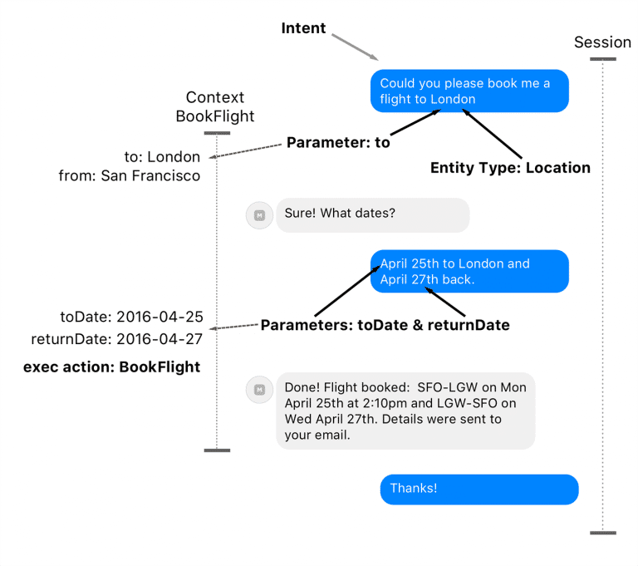

<https://chatbotslife.com/an-overview-of-chatbot-a539b5fc55d3>

A Session usually represents one conversation from beginning to end. An example of one session is when you order a flight from your starting point: ‘*Book a flight to London* ‘(the intent), then through subsequent interactions (questions and answers) you get the information about a booked flight and finish the interaction.

We can use a database to simulate a session management. Here is what we need to do:

* For example, in WhatsApp, use the phone number as the ‘session_id’ and for Facebook messenger bots, use the messenger user id as the ‘session_id’, then map this ‘session_id’ to a ‘data’ field that’s going to contain everything you want to store for that particular user.
* Similarly, we can use the Customer_Id from existing customer database and the current time to create a unique Session_id.
* Also need to define idle time somewhere around 3-5 mins, and if user doesn't respond for 3-5 mins then we can close the session and save it.
* For this we can create a Model called ManageSession which has fillable fields — ‘session_id’ and ‘data’.
* Session_id stores the unique session id and in data an array of variables can be stored.
* And then, we going to define few functions under that model that will perform the store, retrieve and update the variables.

How to manage session variables while building a WhatsApp/Facebook Chatbot

*From <*[*https://medium.com/@mmuoDev/how-to-manage-session-variables-while-building-a-whatsapp-facebook-chatbot-fa20131c8c95*](https://medium.com/@mmuoDev/how-to-manage-session-variables-while-building-a-whatsapp-facebook-chatbot-fa20131c8c95)*>*